**TERM-2 CCNA Assignment**

# Module 7 Network fundamentals

* **Advance Question**

1. **Explain Network Topologies**

**Ans.** A network topology is the physical and logical arrangement of nodes and connections in a network. Nodes usually include devices such as switches, routers and software with switch and router features. Network topologies are often represented as a graph.

1. **Explain TCP/IP Networking Model**

**Ans.** TCP/IP stands for Transmission Control Protocol/Internet Protocol and is a suite of communication protocols used to interconnect network devices on the internet. TCP/IP is also used as a communications protocol in a private computer network (an intranet or extranet).

1. **Explain LAN and WAN Network**

**Ans.** LAN is a computer network established within a small geographic area, such as a house, office or buildings. WAN, on the other side, is a computer network that covers a broad geographical area. LANs allow users to transfer the data faster, whereas WANs have a comparatively slower data transfer rate.

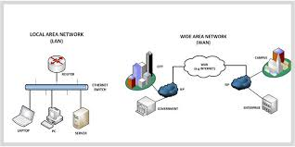

1. **Explain Operation of Switch**

**Ans.** Switches may be operated by process variables such as pressure, temperature, flow, current, voltage, and force, acting as sensors in a process and used to automatically control a system. For example, a thermostat is a temperature-operated switch used to control a heating process.

1. **Describe the purpose and functions of various network devices**

**Ans.** The purpose of networking devices is to enable smooth communication between different hardware connected to a network. Addition of a network device helps in hassle free sharing of network resources between different systems.

1. **Make list of the appropriate media, cables, ports, and connectors to connect switches to other**

**Ans.**

1. **Define Network devices and hosts**

**Ans.** A network node is any device participating in a network. A host is a node that participates in user applications, either as a server, client, or both. A server is a type of host that offers resources to the other hosts. Typically a server accepts connections from clients who request a service function.

1. **What are Ethernet Standard (802.3) and Frame Formats?**

**Ans.** Frame Format of Classic Ethernet and IEEE 802.3

In case of classic Ethernet it is an 8 byte field and in case of IEEE 802.3 it is of 7 bytes. Start of Frame Delimiter: It is a 1 byte field in a IEEE 802.3 frame that contains an alternating pattern of ones and zeros ending with two ones.

* **Intermediate Question**

1. **Comparison between UTP, MM and SM Ethernet Cabling**

**Ans.**

1. **Make Cross cable**

**Ans.** Done in lab.

1. **Make Straight-Through Cable**

**Ans.** Done in lab.

1. **Differentiate between LAN/WAN operation and features**

**Ans. Local Area Network (LAN):** LAN is a group of network devices that allow communication between connected devices. The private ownership has the control over the local area network rather than the public. LAN has a short propagation delay than MAN as well as WAN. It covers the smallest area such as College, School Hospital and so on.

**Wide Area Network (WAN):** WAN covers a large area than LAN as well as MAN such as Country/Continent etc. WAN is expensive and should or might not be owned by one organization. PSTN or Satellite medium is used for wide area networks.

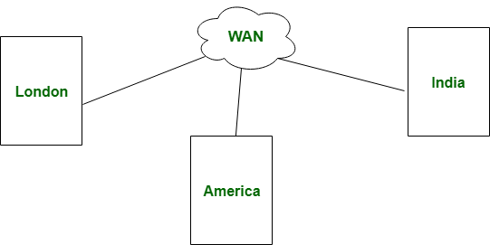

|  |  |  |
| --- | --- | --- |
| S.NO. | LAN | WAN |
|  | LAN stands for Local Area Network. | Whereas WAN stands for Wide Area Network. |
|  | LAN’s ownership is private. | But WAN’s ownership can be private or public. |
|  | The speed of LAN is high(more than WAN). | While the speed of WAN is slower than LAN. |
|  | The propagation delay is short in LAN. | Whereas the propagation delay in WAN is long(longer than LAN). |

1. **Explain ARP, ICMP and Domain name**

**Ans.** DNS translates human-readable host names, such as intronetworks.cs.luc.edu to IP addresses. **ARP translates IPv4 addresses to Ethernet addresses, for destinations on the same LAN**. DHCP assigns IPv4 addresses. And ICMP enables the transmission of IPv4-related error and status messages.

1. **Describe the components required for network and Internet communications**

**Ans.** A network has 5 basic components viz. **clients, servers, channels, interface devices and operating systems**.

1. **Explain Encapsulation and DE capsulation in OSI Reference model**

**Ans.** Encapsulation adds information to a packet as it travels to its destination. Decapsulation reverses the process by removing the info, so a destination device can read the original data.

1. **Explain network segmentation and basic traffic management concepts**

**Ans.** A LAN without any network segments is a single broadcast and collision domain. In a broadcast domain a group of devices on a network hears all the broadcasts

1. **What is flow control and acknowledgment?**

**Ans.** It is a set of measures taken to regulate the amount of data that a sender sends so that a fast sender does not overwhelm a slow receiver. In data link layer, flow control restricts the number of frames the sender can send before it waits for an acknowledgment from the receiver.

* **Advance question**

1. **Use the OSI and TCP/IP models and their associated protocols to explain how data Flows in a network**

**Ans.** The OSI model has never been directly implemented as it’s mostly a reference architecture on how data should flow from one application to another through a network. TCP/IP is used, and these days it’s the most popular. After the OSI model, I will say more about TCP/IP. But it’s good to start with the OSI because it’s easier to understand some of the concepts.

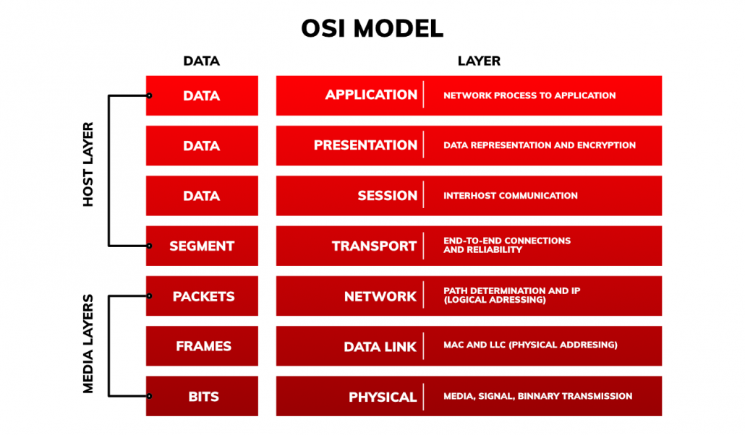

The OSI model consists of 7 layers divided into two groups:

* Host layers (happening on the computer side. Responsible for accurate data delivery between devices)
* Media layers (happening on the network side. Responsible for making sure that the data has arrived at its destination)

### 7. Application layer

In this layer, the user directly interacts with applications. Here is decided which interfaces are used to interact with the network through the corresponding protocols in this layer.

Examples of such applications are chrome or Gmail:

* Chrome uses the HTTP / HTTPS protocol
* Gmail uses email protocols like SMTP, IMAP.

The applications themselves are not in the application layer – in this layer, there are only the protocols or services that the applications use.

### 6. Presentation layer

The task of this layer is proper data representation, compression/decompression, encryption/decryption. This ensures that the data sent from the X system application layer can be read by the Y system application layer.

### 5. Session layer

This layer is responsible for creating, managing, and then closing sessions between two applications that want to communicate with each other.

### 4. Transport layer

The task of this layer is to make sure that the data has arrived safely from the sender to the recipient. When it sends data, it breaks it into segments. When it accepts data, it puts it back into a stream of data.

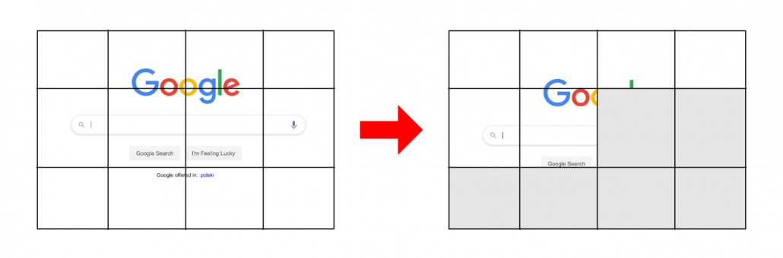

In this layer two protocols are used: TCP and UDP (later on in the article I’ll be saying more about these)

### 3. Network layer

Provides addressing and routing services. It defines which routes connect individual computers and decides how much information to send using one connection or another. Data transferred through this layer are called packets.

Places two addresses in the packet sent:

* Source address
* Destination address

This layer is based on IP (internet protocol).

### 2. Data-link layer

This layer deals with packing data into frames and sending them to the physical layer. It also oversees the quality of the information provided by the physical layer. It recognizes errors related to losing packages and damaging frames and deals with their repair.

### 1. Physical layer

This is the physical aspect of the network. This applies to cables, network cards, WIFI, etc. It is only used to send logical zeros and ones (bits). It determines how fast the data flows. When this layer receives frames from the data link layer, it changes them to a bitstream.

## Encapsulation and decapsulation of data

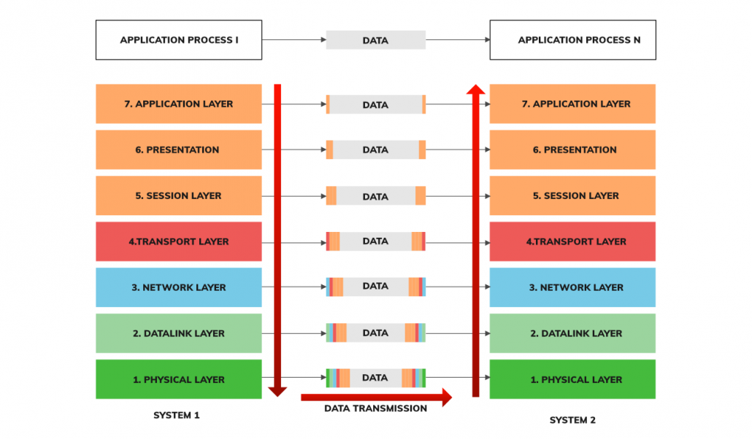

**Encapsulation** adds pieces of information to data sent over the network. This occurs when we send data. At each layer, some information is added to our data. We combine the address of the sender and recipient, the encryption method, data format, how the data will be divided, sent, etc.

**Decapsulation** occurs when we receive information. It consists of removing pieces of information collected from the network. At each layer, some info disappears. In the end, the user only gets what he should receive without the IP, MAC address, etc.

1. **Identify and explain at layers 1, 2, 3, and 7 using a layered model approach**

**Ans.**

1. **Explain CSMA/CD and CSMA/CA**

**Ans.** CSMA/CD stands for **Carrier Sense Multiple Access / Collision Detection** is a network protocol for carrier transmission. It is operated in the medium access control layer.

CSMA/CA stands for **Carrier Sense Multiple Access / Collision Avoidance** is a network protocol for carrier transmission.

|  |  |  |
| --- | --- | --- |
| **S.NO.** | **CSMA/CD** | **CSMA/CA** |
|  | CSMA / CD is effective after a collision. | Whereas CSMA / CA is effective before a collision. |
|  | CSMA / CD is used in wired networks. | Whereas CSMA / CA is commonly used in wireless networks. |
|  | It only reduces the recovery time. | Whereas CSMA/ CA minimizes the possibility of collision. |
|  | CSMA / CD resends the data frame whenever a conflict occurs. | Whereas CSMA / CA will first transmit the intent to send for data transmission. |

1. **Explain this frame and find layer**

**Ans.** Framing is a point-to-point connection between two computers or devices consists of a wire in which data is transmitted as a stream of bits. Framing is a function of the data link layer. Framing is a function of the data link layer.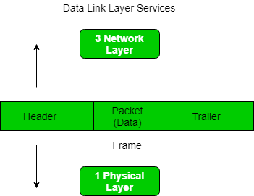

1. **Draw and explain Cisco hierarchical model**

**Ans.** This model consists of three layers:

1. The Access Layer
2. The Distribution Layer
3. The Core Layer

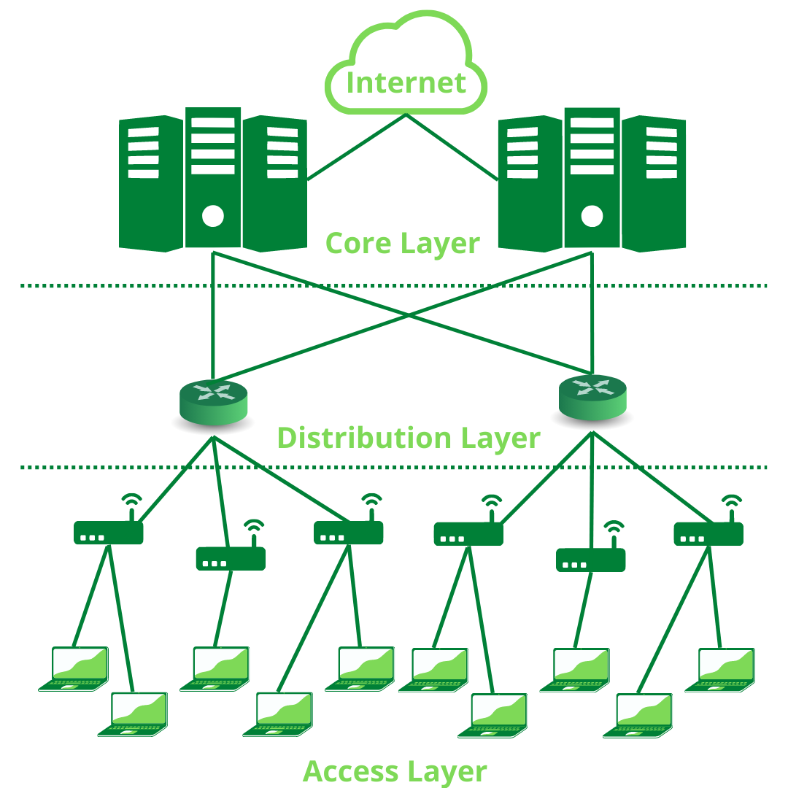

### **Access Layer:**

The Access Layer is the part of the network which enables the users to connect to the wired Ethernet Network. It enables the users to share data and resources on the local network. The devices used in this layer include [Ethernet](https://www.geeksforgeeks.org/ethernet-frame-format/) Switches and Hubs.

### **Distribution Layer:**

When a network grows beyond a certain size, it must be divided into multiple local (Access Layer) networks. the distribution layer connects these networks together. It ensures that local traffic remains confined to local networks and governs traffic control between these networks.

### **Core Layer:**

This layer is considered the backbone of a network, as it is used to connect multiple Distribution Layer devices together. This layer uses the most powerful devices to manage the traffic between the networks. The speed at which data flows in this layer is upwards of [10 Gigabit Ethernet](https://www.geeksforgeeks.org/10-gigabit-ethernet/). This layer has the maximum number of redundant connections (Redundancy is the process of introducing extra connections between the same network points to ensure reliable data transfer even if one of the connections is down) in order to ensure reliable connectivity.

1. **Drawing of a typical wired and wireless enterprise LAN**

**Ans.** Done in lab.

1. **Describe the uses of straight-through and crossover Ethernet cables**

**Ans.** Straight-through cables are mainly used for connecting non-similar devices, while crossover cables are mostly used for connecting similar devices. Straight-through cable connects a computer with a DSL modem, while Crossover cable connects Router to Router and Computer to Computer.

1. **Explain Layer 2 and Layer 3 Switch**

**Ans.** Layer 2 switch work on layer 2 of OSI model i.e. data link layer and sends a “Frames” to destination port using MAC address table which stores the mac address of a device associated with that port. Layer 3 switch work on layer 3 of OSI model i.e. network layer where it route packet by using IP address, it is used widely on VLANs.

|  |  |
| --- | --- |
| **Layer 2 switch** | **Layer 3 switch** |
| Operate on layer 2 (Data link) of OSI model. | Operate on layer 3 (Network Layer) of OSI model. |
| Send “frames” to destination on the basis of MAC address. | Route Packet with help of IP address |
| Work with MAC address only | Can perform functioning of both 2 layer and 3 layer switch |
| Used to reduce traffic on local network. | Mostly Used to implement VLAN (Virtual Local area network) |

1. **Identifying Collision and Broadcast Domains**

**Ans.** The Collision domain is a network section that allows traffic to flow forward and backward. A Broadcast domain is a type of Domain wherein traffic flows all over the network. The Collision domain refers to a set of devices in which packet collision could occur.

1. **Explain Spanning Tree Protocol**

**Ans.** Spanning Tree Protocol (STP) is a Layer 2 network protocol used to prevent looping within a network topology. STP was created to avoid the problems that arise when computers exchange data on a local area network (LAN) that contains redundant paths.

1. **Explain unicast Multicast and Broadcast**

**Ans. Unicast :-** A Unicast communication is from one device on the network to another device on the network.

**Multicast** :- A Multicast communication is from one device on the network to many, but not all, devices on the network.

**Broadcast** :- A Broadcast communication is from one device on the network to all devices on the network.

1. **Explain CAM (Content Addressable Memory)**

**Ans.** Content-addressable memory (CAM) is a special type of computer memory used in certain very-high-speed searching applications. It is also known as associative memory or associative storage and compares input search data against a table of stored data, and returns the address of matching data.

1. **Explain TCAM (Ternary Content Addressable Memory)**

**Ans.** TCAM (ternary content-addressable memory) is a specialized type of high-speed memory that searches its entire contents in a single clock cycle. The term “ternary” refers to the memory's ability to store and query data using three different inputs: 0, 1 and X.

1. **Which command use of Show MAC TABLE?**

**Ans.** To display the MAC table, enter the **show mac-address** command. In the output of the show mac-address command, the Type column indicates whether the MAC entry is static or dynamic. A static entry is one you create using the static-mac-address command.